**Instruction guide for software Crack Extraction and Analysis**

1. Software interface

As shown in Figure 1:

is the button to import image.

is the button to save the image shown in the image area.

is the button to save crack features data to excel.

is the button to select the two endpoints of a crack. When the button pressed, the status bar will prompt "Picking mode" and this can be canceled by clicking right mouse button.

is the button to search the crack. When the two endpoints are not selected, it is disabled.

is the checkbox to invert the image color. If the crack in the image is not relatively dark, please check this box.

is the checkbox and textbox for region growing threshold. If the checkbox is not checked, the software will use the default formula to calculate the threshold. Otherwise, the threshold can be set in the textbox by user-defined.

is the checkbox to pre-smooth the image. If this box is checked, the software will use Gussian fuzzy operation to pre-smooth the image before the image is used for other operations.

is the button to delete the selected crack in .

is a display area for crack features data and the crack can be chosen here.

is the button to select two calibration points, and after selection, the program gives the measure distance between these two points.

is the textbox the input the actual distance between the two points in .

is the button to calculate the size of each pixel which is shown in pixel size textbox. This pixel size is calculated by formula actual distance/measure distance.

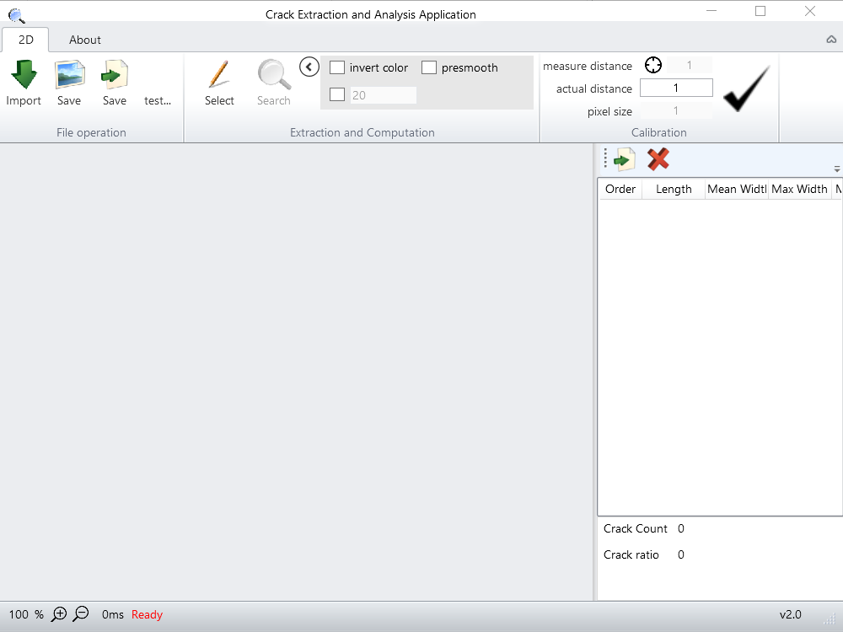

Figure 1 Software interface

2. Use of the software

The user should first import the image by clicking the import button. Then the user should choose the two endpoints of the identified crack and before clicking the search button, and the optional parameters can be set by the checkboxes on the right side.

If the image contains more than one crack, the user should choose the two endpoints of each crack respectively. That means the user should select endpoints and then search the crack and repeat these operations.

After all the cracks are searched, the crack features data can be saved to excel by clicking the save data button.

Note: the calibration can be processed at any time. After the pixel size is updated, the feature values are automatically updated.